CONFIDENTIAL  CS/NOV 2026/ICT450

UNIVERSITI TEKNOLOGI MARA
MARKING SCHEME

COURSE :
COURSE CODE :
EXAMINATION :
TIME :
DATABASE DESIGN AND DEVELOPMENT
ICT450
NOVEMBER 2026 (MOCK)
3 HOURS

MARKING SCHEME NOTES

- This marking scheme accompanies the ICT450 mock paper (November 2026).
Answers are unofficial model answers, not official UTM marking schemes.

- Marking points state the expected answer and the allocation of marks; every question retains its source paper and page reference.

- Five questions x 20 marks; total = 100 marks.
- Real-bank questions: 5. Placeholders: 0.
Questions and answers are for local study use only.

- Structure derived from 12 unique ICT450 past papers; every real question remains traceable to its source page.

FOR MARKERS' USE ONLY

This marking scheme consists of 7 printed pages.
MARKING GUIDE
QUESTION 1 (20 marks)
Source: ICT450-2019-DEC · page [2] · bank id ICT450-2019-DEC-Q1
Reference answer
(a) Data anomalies and big data in healthcare. [8 marks]
• i) Insertion anomaly — a new fact cannot be stored without inventing an unrelated fact; update anomaly — the same fact must be changed in several places and may become inconsistent; deletion anomaly — deleting one fact accidentally removes another.
• ii) Predictive healthcare analytics — hospital data is analysed to predict readmission risk; example: a model flags diabetic patients for follow-up.
• Population health and disease surveillance — large datasets track outbreaks and health trends; example: regional dashboards for influenza cases.
(b) How data redundancy occurs in a file system. [8 marks]
• The same customer or product data is stored in several independent files, such as an orders file and an invoices file.
• Each department maintains its own copy, so a change in one file is not reflected in the others.
• The result is wasted storage, inconsistent values and update anomalies.
(c) How referential integrity is enforced. [4 marks]
• A foreign key in the child table must either match an existing primary-key value in the parent table or be NULL.
• The DBMS rejects inserts, updates or deletes that would leave an orphan child row.
Marking guide
• a)(i) 2 marks for each of two anomalies (4).
• a)(ii) 2 marks for each healthcare application with example (4).
• b) 8 marks for a clear description of redundancy and its consequences.
• c) 4 marks for the FK rule and the DBMS enforcement action.
Provenance: model_unofficial · confidence medium · Model-authored from the approved question text, the supplied source assets and the ICT200/ICT450 knowledge base; no official ICT450 marking scheme was supplied.
Knowledge base basis: TOPIC 1 DATABASE CONCEPT (1).pdf; TOPIC 2 DATA MODEL (1).pdf; TOPIC 3 RELATIONAL DATA MODELstu.pdf
Assumptions / notes
• Figure 1.0 is answered as a generic parent-child ERD because the figure is an image crop; the referential-integrity rule is the same for any FK.

QUESTION 2 (20 marks)
Source: ICT450-2026-FEB · page [2] · bank id ICT450-2026-FEB-Q2
Reference answer
(a) Two basic features of the relational model. [4 marks]
• Data is organised as relations (tables) of rows and columns, with each column drawn from a domain.
• Keys and integrity constraints link tables and enforce uniqueness, entity integrity and referential integrity.
(b) Two domain constraints. [4 marks]
• Data-type and format constraint — a salary column must be numeric, and a phone number must follow a pattern.
• Range or check constraint — a salary must lie between 3000 and 10000; a grade must be one of A, B, C, D, E or F.
(c) Three anomalies in a denormalized table. [6 marks]
• Insertion anomaly — a new product cannot be added without inventing a customer order.
• Update anomaly — a customer address must be changed in every row where it appears.
• Deletion anomaly — deleting an order may also delete the only record of a product or customer.
(d) Three mobile-database challenges with examples. [6 marks]
• Intermittent connectivity — a field officer loses the network while updating a record.
• Limited device storage and battery — a phone cannot hold the whole central database.
• Security and synchronization — a lost device may expose data, and offline edits must be merged safely.
Marking guide
• a) 2 marks for each feature (4).
• b) 2 marks for each domain constraint with example (4).
• c) 2 marks for each anomaly with example (6).
• d) 2 marks for each challenge with example (6).
Provenance: model_unofficial · confidence high · Model-authored from the approved question text, the supplied source assets and the ICT200/ICT450 knowledge base; no official ICT450 marking scheme was supplied.
Knowledge base basis: TOPIC 2 DATA MODEL (1).pdf; TOPIC 6 DATABASE DESIGN (1).pdf

QUESTION 3 (20 marks)
Source: ICT450-2018-JUN · page [3, 4] · bank id ICT450-2018-JUN-Q3
Reference answer
The table mixes course, tutor and student data. The student rows repeat for the course, so the data is flattened to one row per student before normalisation.
(a) Normal form of Table 1.0. [3 marks]
• The table is in first normal form (1NF) when flattened to one row per student, because each cell is atomic and a key can be formed.
• It is not in 2NF or 3NF because student data depends only on StudentID, tutor data depends on CourseCode, and TutorName depends transitively on TutorID.
(b) Dependency diagram and partial/transitive dependencies. [7 marks]
Functional dependencies.
CourseCode → CourseName, TutorID, TutorName
TutorID → TutorName
StudentID → StudentName, DOB, Gender
CourseCode, StudentID → LastAttendanceDate
Partial dependencies: CourseCode → CourseName/TutorID/TutorName and StudentID → StudentName/DOB/Gender. Transitive dependency: CourseCode → TutorID → TutorName.
(c) Normalise to 3NF. [10 marks]
1NF: one row per course-student attendance; key (CourseCode, StudentID).
2NF: remove partial dependencies into COURSE, STUDENT and ATTENDANCE.
2NF relations.
COURSE (CourseCode, CourseName, TutorID, TutorName)
STUDENT (StudentID, StudentName, DOB, Gender)
ATTENDANCE (CourseCode, StudentID, LastAttendanceDate)
3NF: remove TutorID → TutorName from COURSE.
3NF relations.
COURSE (CourseCode, CourseName, TutorID)
TUTOR (TutorID, TutorName)
STUDENT (StudentID, StudentName, DOB, Gender)
ATTENDANCE (CourseCode, StudentID, LastAttendanceDate)
3NF sample data: COURSE and TUTOR
CourseCode | CourseName | TutorID | TutorName
ICT450 | Database Design and Development | 306612 | Professor Albus Dumbledore

Marking guide
• a) 3 marks: 1NF identified, with reasons why 2NF/3NF fail.
• b) 7 marks: dependency diagram (3), partial dependencies (2), transitive dependency (2).
• c) 10 marks: 1NF (2), 2NF (4), 3NF (4).
Provenance: model_unofficial · confidence high · Model-authored from the approved question text, the supplied source assets and the ICT200/ICT450 knowledge base; no official ICT450 marking scheme was supplied.
Knowledge base basis: TOPIC 5 NORMALIZATION (1).pdf
Assumptions / notes
• The table is treated as one course with a repeating list of enrolled students.

QUESTION 4 (20 marks)
Source: ICT450-2018-DEC · page [2, 3] · bank id ICT450-2018-DEC-Q3
Reference answer
Football league schema.
TEAM (TEAM_ID, TEAM_NAME)
GAME (GAME_ID, GAME_NAME)
FOOTBALL (FOOTBALL_ID, TEAM_ID*, GAME_ID*, DATE, TIME, LOCATION)
PLAYER (PLAYER_ID, P_NAME, ADDRESS, PHONE_NO, SALARY, POSITION, TEAM_ID*)
(a) Create the PLAYER table with integrity requirements. [3 marks]
CREATE TABLE PLAYER (
PLAYER_ID VARCHAR(10) NOT NULL,
P_NAME VARCHAR(60) NOT NULL,
ADDRESS VARCHAR(150),
PHONE_NO VARCHAR(20),
SALARY DECIMAL(12,2) CHECK (SALARY >= 0),
POSITION VARCHAR(30),
TEAM_ID VARCHAR(10) NOT NULL,
PRIMARY KEY (PLAYER_ID),
FOREIGN KEY (TEAM_ID) REFERENCES TEAM (TEAM_ID)
);
(b) Insert the specified player row. [2 marks]
INSERT INTO PLAYER
(PLAYER_ID, P_NAME, ADDRESS, PHONE_NO, SALARY, POSITION, TEAM_ID)
VALUES
('10067', 'Safiq Rahim',
'No.168, Damai Country Height, 40100, Shah Alam, Selangor',
'019-3451212', 30000.00, 'Defence', 'FAM326');
(c) Give strikers of The Red Warrior a 10% increment. [2 marks]
UPDATE PLAYER
SET SALARY = SALARY * 1.10
WHERE POSITION = 'Striker'
AND TEAM_ID = (SELECT TEAM_ID
FROM TEAM
WHERE TEAM_NAME = 'The Red Warrior');
(d) Teams that played at Bukit Jalil in May 2018. [3 marks]
SELECT DISTINCT t.*
FROM TEAM t
JOIN FOOTBALL f ON f.TEAM_ID = t.TEAM_ID
WHERE f.LOCATION = 'Bukit Jalil National Stadium'
AND f.DATE BETWEEN DATE '2018-05-01' AND DATE '2018-05-31';
(e) Number of games in the first quarter of 2018. [3 marks]
SELECT COUNT(DISTINCT GAME_ID) AS total_games
FROM FOOTBALL
WHERE DATE BETWEEN DATE '2018-01-01' AND DATE '2018-03-31';
(f) Number of games played by each team. [3 marks]
SELECT TEAM_ID, COUNT(DISTINCT GAME_ID) AS games_played
FROM FOOTBALL
GROUP BY TEAM_ID;
(g) Teams and players at Merdeka Stadium with salary 2000 or 3000. [4 marks]
SELECT DISTINCT t.TEAM_NAME, p.P_NAME
FROM TEAM t
JOIN PLAYER p ON p.TEAM_ID = t.TEAM_ID
JOIN FOOTBALL f ON f.TEAM_ID = t.TEAM_ID
WHERE f.LOCATION = 'Merdeka Stadium'
AND p.SALARY IN (2000, 3000);
Marking guide
• a) 3 marks: columns (1), primary key (1), foreign key (1).
• b) 2 marks: correct INSERT with all values.
• c) 2 marks: UPDATE with striker/team predicate and 10%.
• d) 3 marks: team-football join (2), location/date filter (1).
• e) 3 marks: COUNT DISTINCT game and Q1 date range.
• f) 3 marks: GROUP BY team and COUNT DISTINCT game.
• g) 4 marks: three-table join (2), location filter (1), salary IN (1).
Provenance: model_unofficial · confidence high · Model-authored from the approved question text, the supplied source assets and the ICT200/ICT450 knowledge base; no official ICT450 marking scheme was supplied.
Knowledge base basis: TOPIC 7 SQL.pdf
Assumptions / notes
• Data types are not printed; reasonable types are chosen. Dates use ISO literals in the examples.

QUESTION 5 (20 marks)
Source: ICT450-2019-JUN · page [6] · bank id ICT450-2019-JUN-Q5
Reference answer
The ERD models clients, projects, employees, jobs and assignments. Employees may hold many jobs and work on many projects; one employee leads and another coordinates each project.
(a) Construct the ERD with Crow's Foot notation. [16 marks]
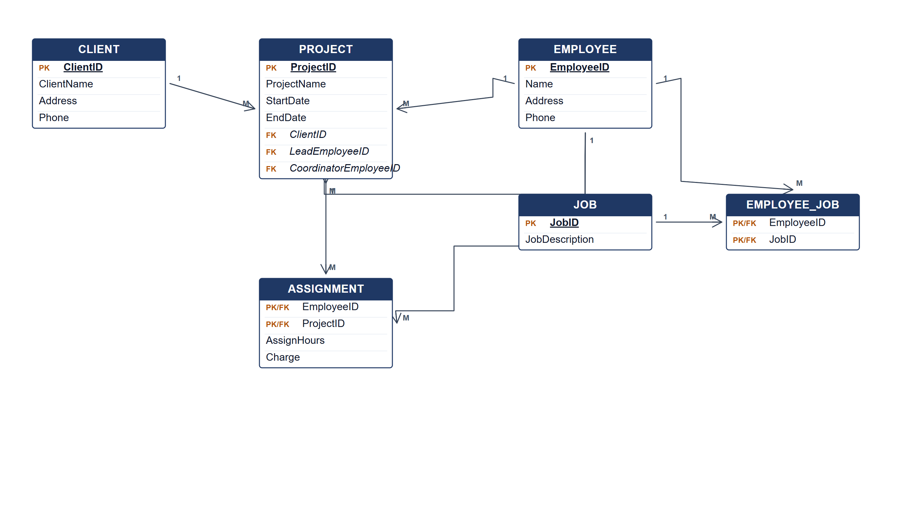
BestEverConsult ERD.
(b) Two reports from the ERD. [4 marks]
• Project staffing report — employees assigned to each project with hours and charge.
• Employee utilisation report — jobs held and projects assigned per employee.
Marking guide
• a) 16 marks: client/project/employee/job entities (5); job and assignment associative entities (4); lead/coordinate/assignment relationships (5); keys (2).
• b) 2 marks for each report (4).
Provenance: model_unofficial · confidence medium · Model-authored from the approved question text, the supplied source assets and the ICT200/ICT450 knowledge base; no official ICT450 marking scheme was supplied.
Knowledge base basis: TOPIC 4 ERD_stu (2).pdf; TOPIC 3 RELATIONAL DATA MODELstu.pdf
Assumptions / notes
• Lead and coordinate are optional roles; the diagram labels them 0..1 in the answer text and uses one-side Crow's Foot for readability.

